Raju Rishikesh Gollapally Business Analytics Assignment-1
#Install the ISLR library operating the install.packages() command. #install.packages(“ISLR”) #As this ISLR package is already installed it will not reveal any error that the package is already installed.
#Calling the ISLR library using the library(ISLR) command to ensure that the library is correctly installed.
library(ISLR)
#Considering the data set file Carseats that is present in the ISLR Library.
View(Carseats)
#Printing the summary of the Carseats dataset
summary(Carseats)
## Sales CompPrice Income Advertising
## Min. : 0.000 Min. : 77 Min. : 21.00 Min. : 0.000
## 1st Qu.: 5.390 1st Qu.:115 1st Qu.: 42.75 1st Qu.: 0.000
## Median : 7.490 Median :125 Median : 69.00 Median : 5.000
## Mean : 7.496 Mean :125 Mean : 68.66 Mean : 6.635
## 3rd Qu.: 9.320 3rd Qu.:135 3rd Qu.: 91.00 3rd Qu.:12.000
## Max. :16.270 Max. :175 Max. :120.00 Max. :29.000
## Population Price ShelveLoc Age Education
## Min. : 10.0 Min. : 24.0 Bad : 96 Min. :25.00 Min. :10.0
## 1st Qu.:139.0 1st Qu.:100.0 Good : 85 1st Qu.:39.75 1st Qu.:12.0
## Median :272.0 Median :117.0 Medium:219 Median :54.50 Median :14.0
## Mean :264.8 Mean :115.8 Mean :53.32 Mean :13.9
## 3rd Qu.:398.5 3rd Qu.:131.0 3rd Qu.:66.00 3rd Qu.:16.0
## Max. :509.0 Max. :191.0 Max. :80.00 Max. :18.0
## Urban US
## No :118 No :142
## Yes:282 Yes:258
##
##
##
##
#Printing the maximum value of the advertising attribute that is present in Carseats datset.
max(Carseats$Advertising)
## [1] 29
#Printing the maximum value of the Price attribute that is present in Carseats datset.
max(Carseats$Price)
## [1] 191
#Summing up the Inter Quartile Range(Upper Range-Lower range) of the Price attribute
IQR(Carseats$Price)
## [1] 31
#Summing up the correlation between Sales VS Price #Conspiring the Sales against Price
plot(Carseats$Sales,Carseats$Price,main = "Ploting the sales againest Price", xlab="sales", ylab = "Price")
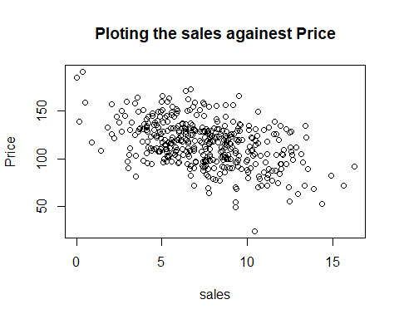 #In This graph plot shows both the attributes Sales and Price in the y-axis and x-axis respectively. We can also see the pattern of the plots as to how the design is slant downwards.

Calculating the correlation of the two attributes(sales vS Price).
cor.test(Carseats$Sales, Carseats$Price, method = c("pearson"))
##
## Pearson's product-moment correlation
##
## data: Carseats$Sales and Carseats$Price
## t = -9.912, df = 398, p-value < 2.2e-16
## alternative hypothesis: true correlation is not equal to 0
## 95 percent confidence interval:
## -0.5203026 -0.3627240
## sample estimates:
## cor
## -0.4449507
#The result we obtained from the code is -0.4449507. The negative symbol indicates that the correlation coeffecient is weakly neagtive. The plot graph design also shows the same pattern.

